## **a.**

### **Q.N.1**

The current form of the given order information table is in a traditional database system. Traditional DB uses Structured Query Language. SQL is suitable for small volume and structured data but not for Big Data concepts. It is better to use NoSQL DB than the traditional DB because the volume of data of Condor Building Services Ltd can grow at a very large scale due to high numbers of ordering in the future. After this, the use of SQL DB will enormously decrease the performance speed of the system while dealing with the Order’s data.

NoSQL DB handles data at very high speed dealing with large volumes of data. It uses scale-out architecture. It can easily store and retrieve structured, unstructured, and semi-structured data. It provides easy updates to the fields and the schemas. It’s developer-friendly and can give zero downtime by taking full advantage of the cloud (n.d., 2021).

### **Q.N.2**

MongoDB has been used to design the database of the given order information. The queries used to design the database are shown below.

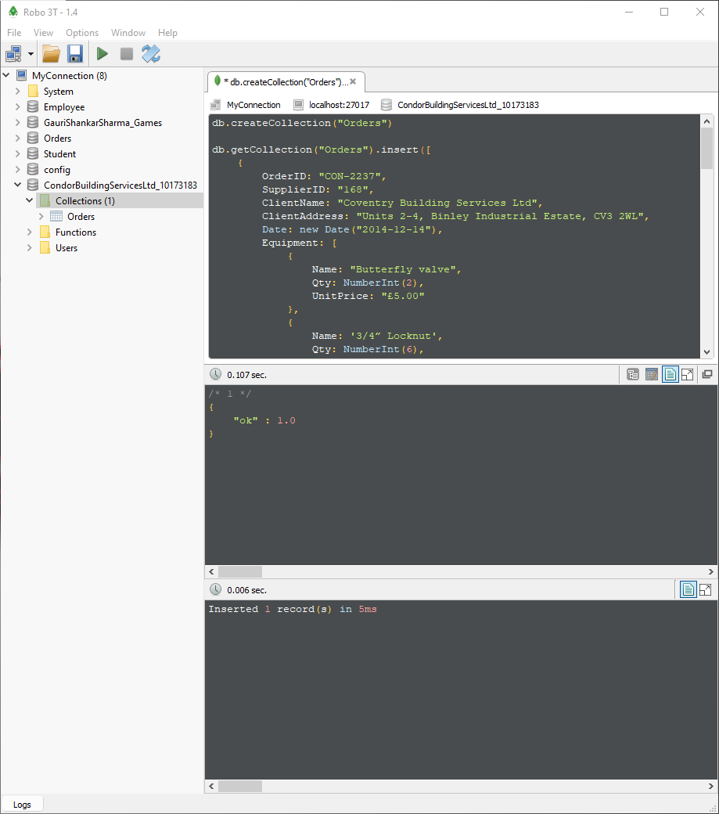

Figure 1: Creating the database for the given order information

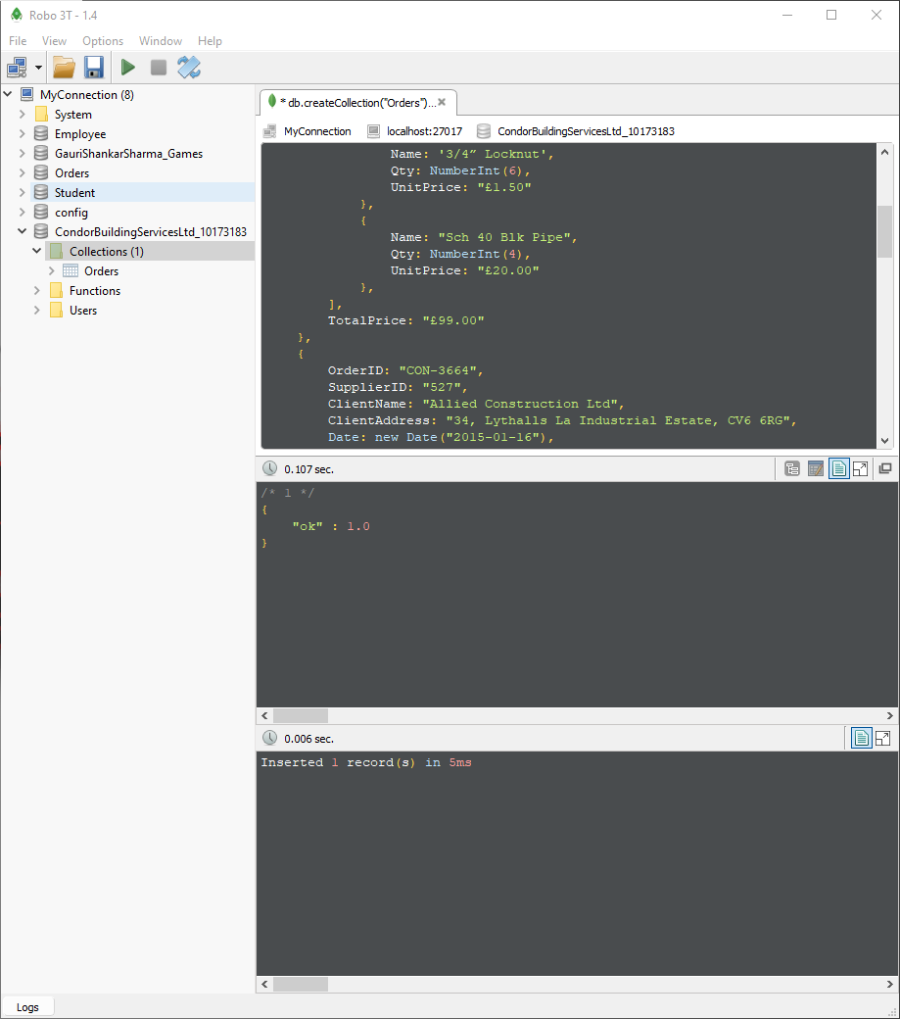

Figure 2: Creating the database for the given order information

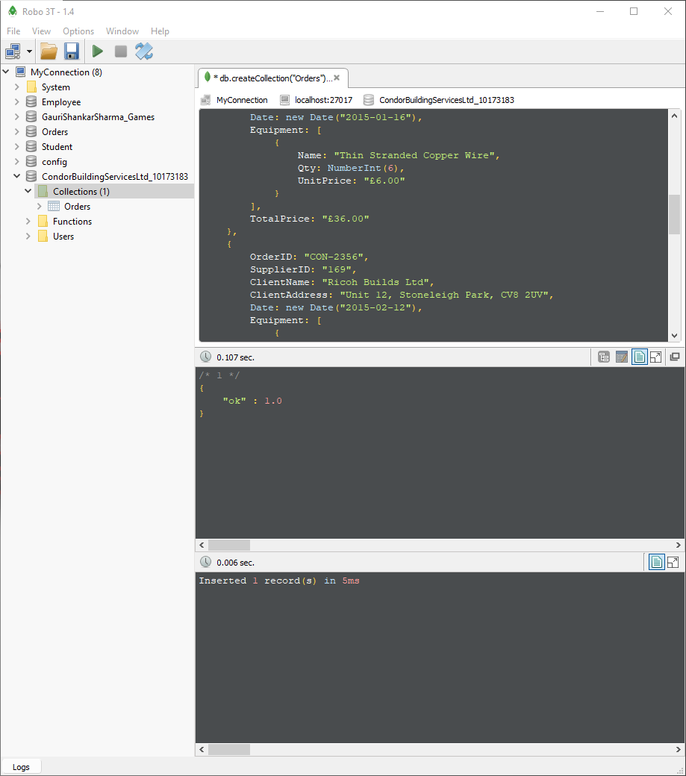

Figure 3: Creating the database for the given order information

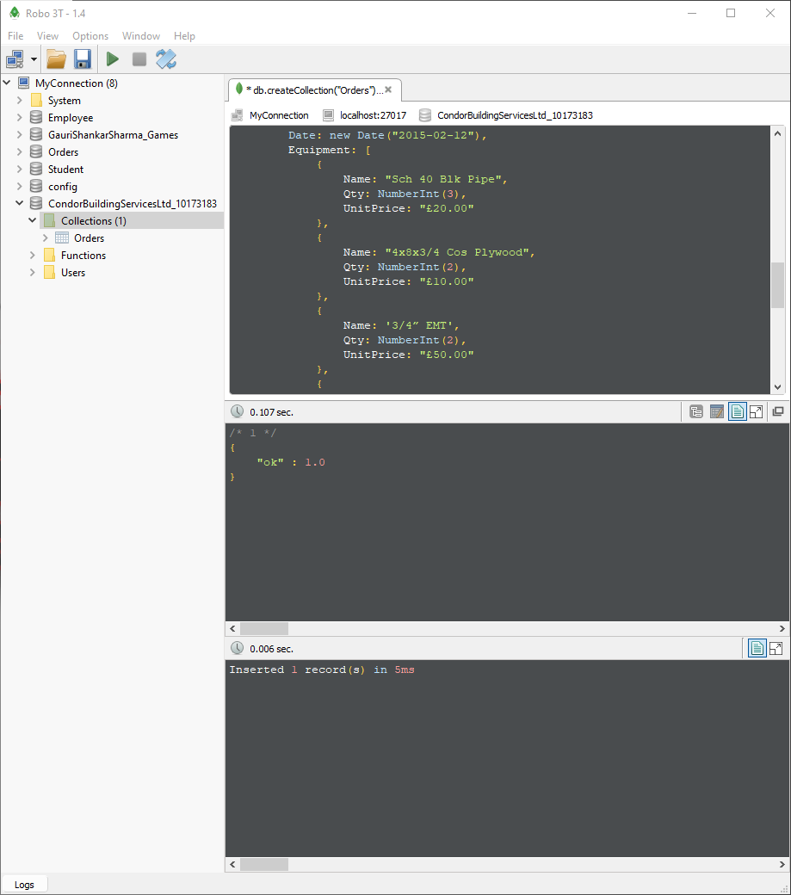

Figure 4: Creating the database for the given order information

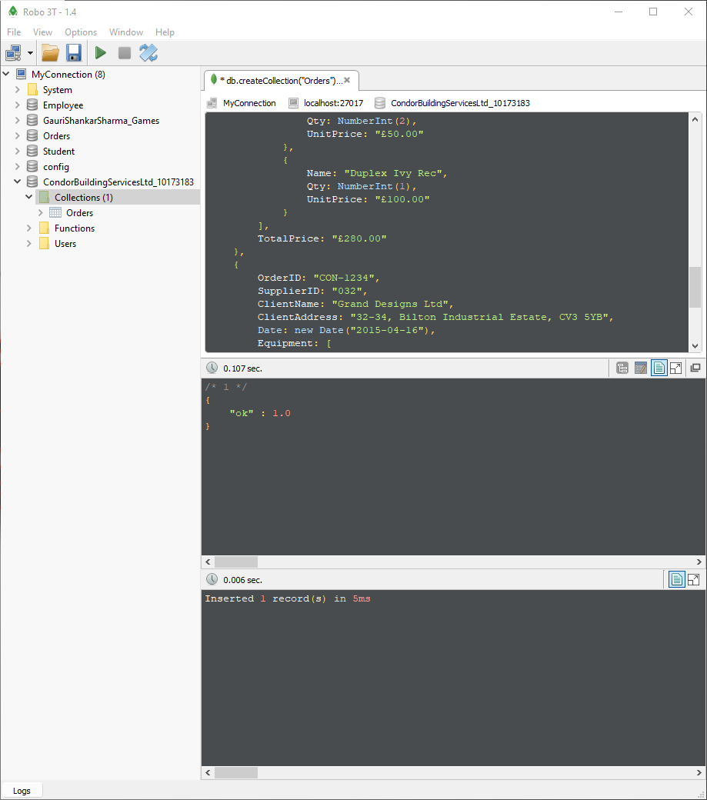

Figure 5: Creating the database for the given order information

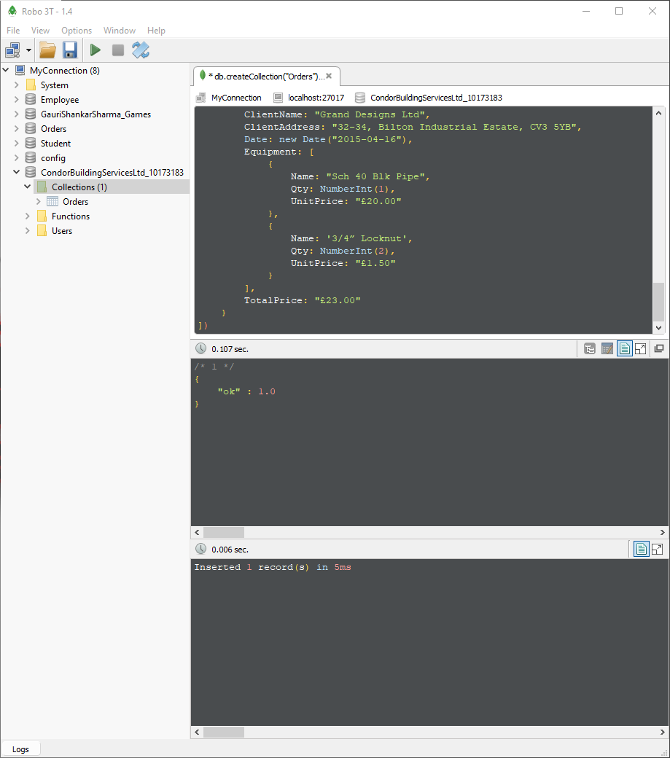

Figure 6: Creating the database for the given order information

## **b.**

### **Q.N.1**

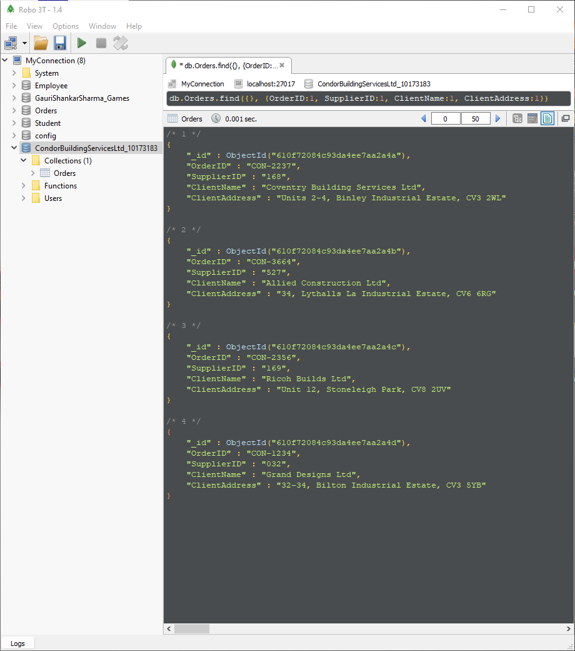

Figure 7: Displaying all the client details with its order.

### **Q.N.2**

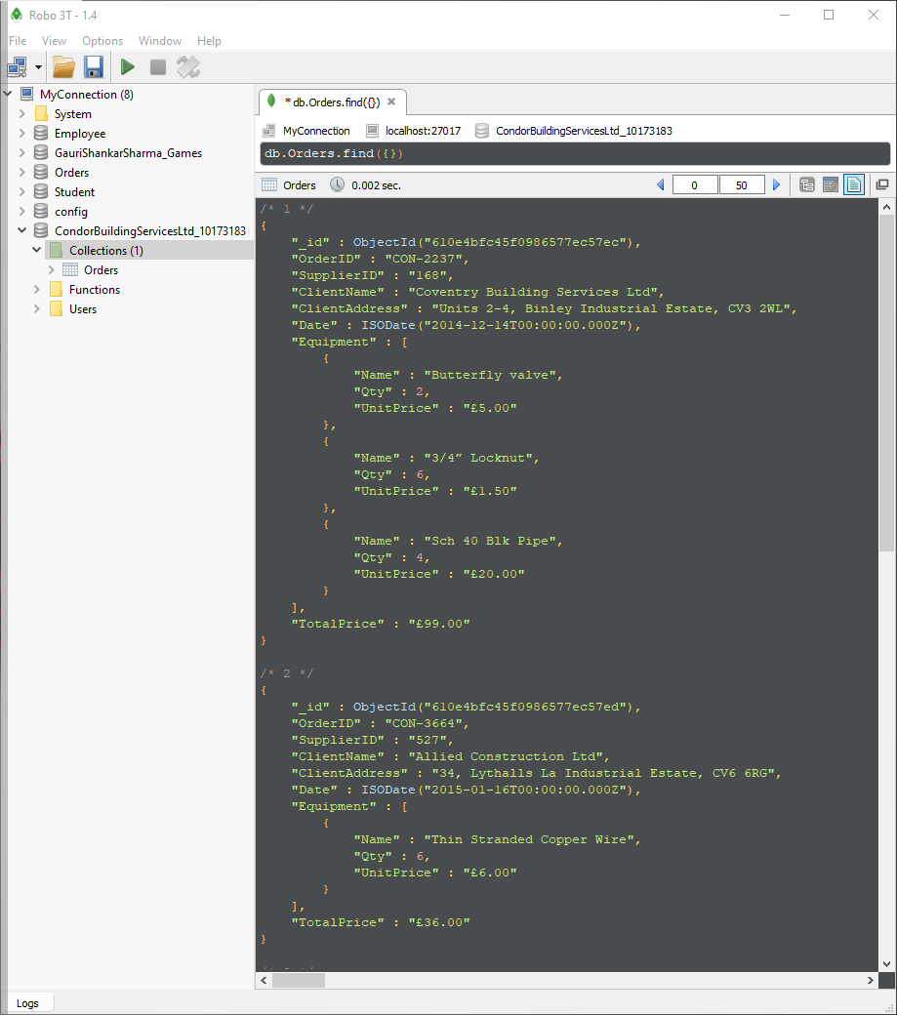

Figure 8: Display all the order details with its client name and equipment associate with it.

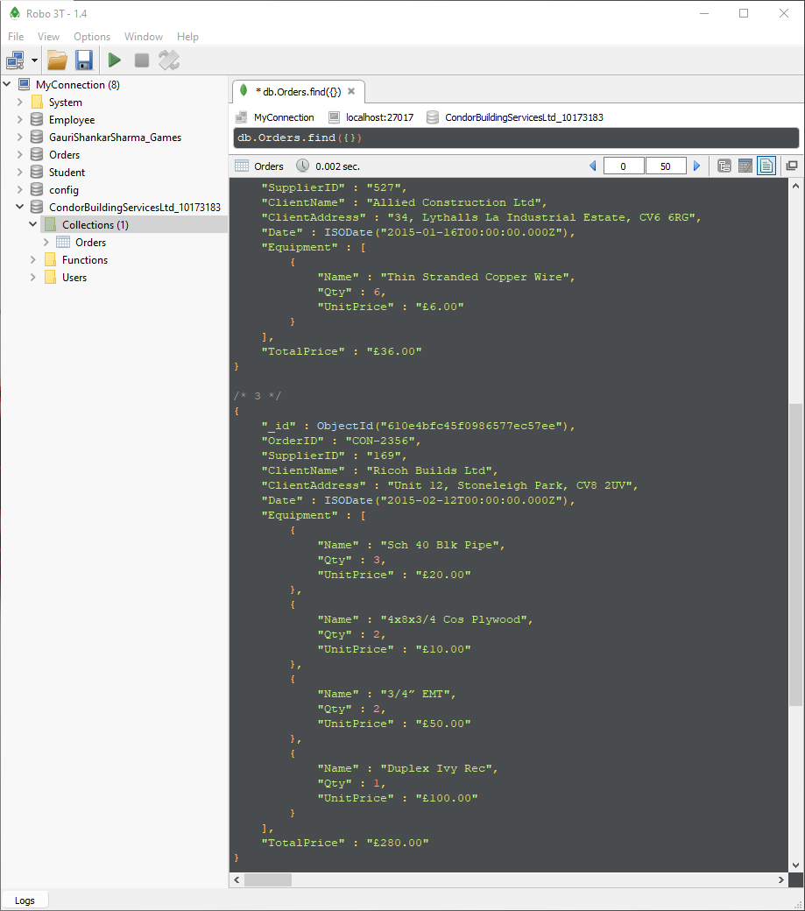

Figure 9: Display all the order details with its client name and equipment associate with it.

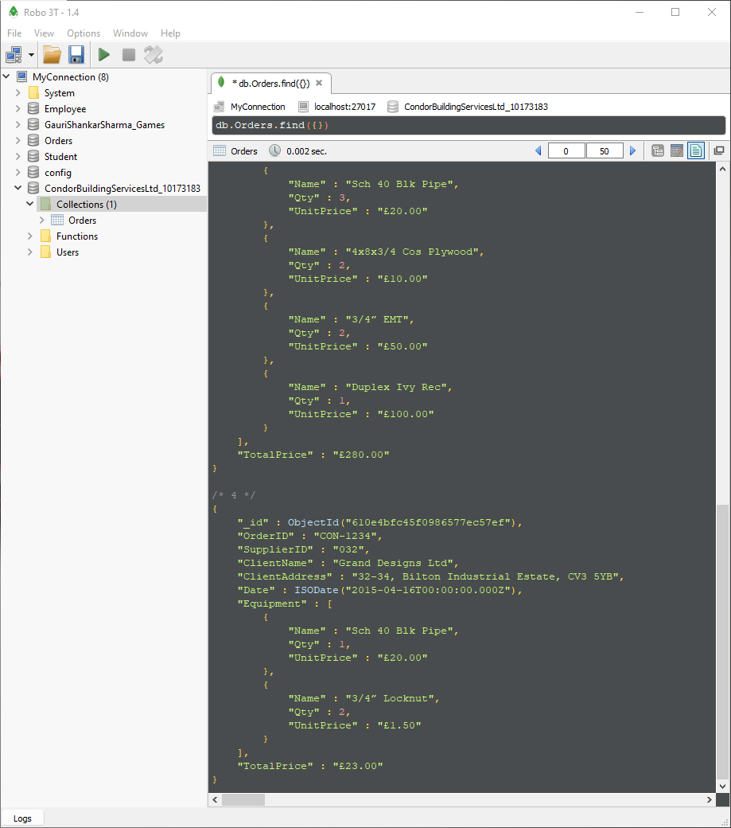

Figure 10: Display all the order details with its client name and equipment associate with it.

### **Q.N.3**

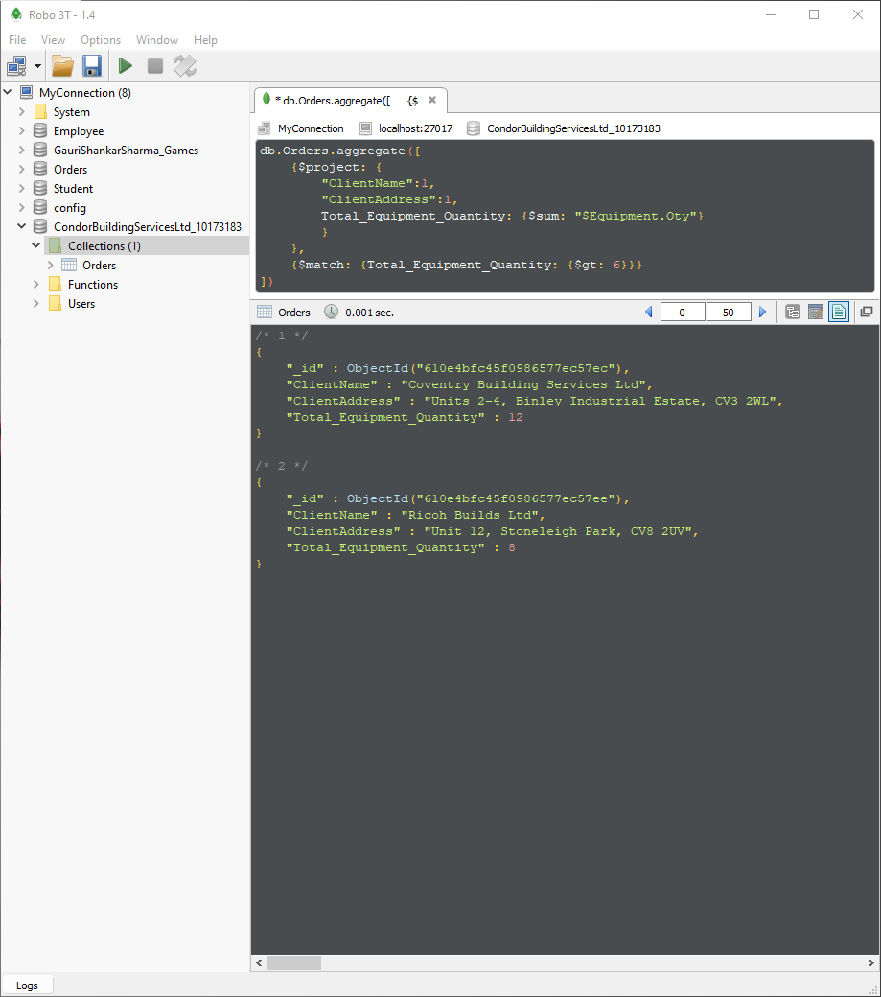

Figure 11: Displaying all the client details whose total equipment quantity is more than 6.

### **Q.N.4**

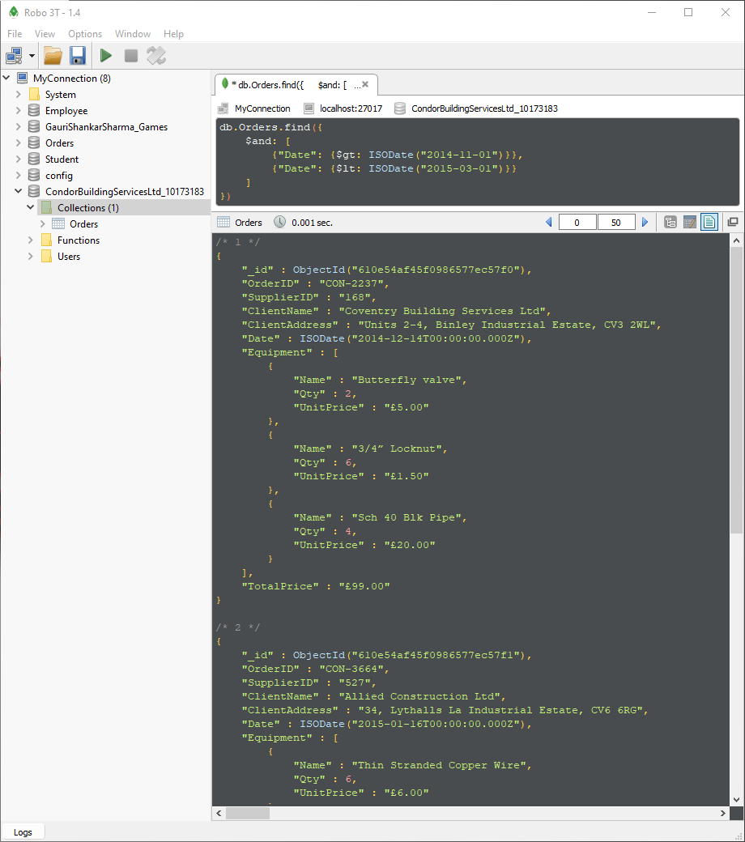

Figure 12: Displaying all the equipment ordered between 01/11/2014 and 01/03/2015.

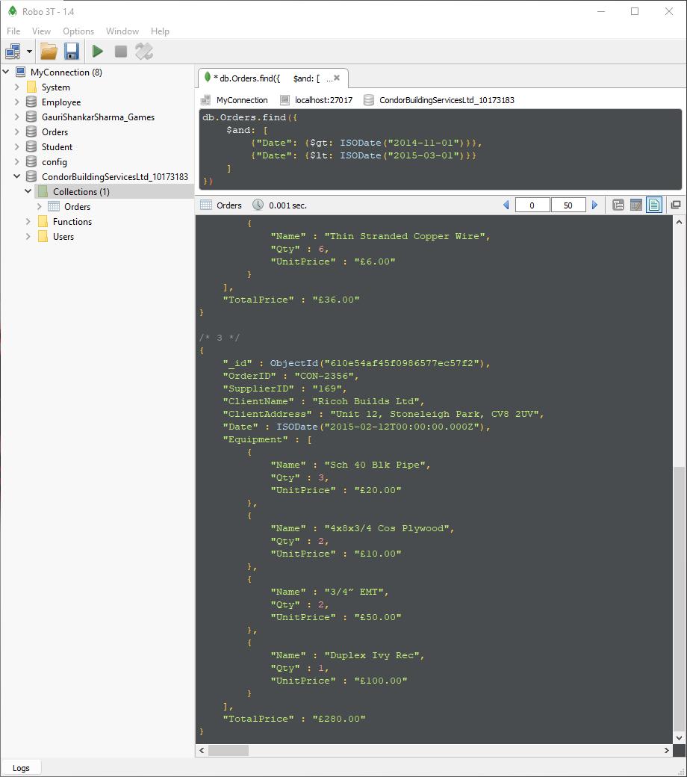

Figure 13: Displaying all the equipment ordered between 01/11/2014 and 01/03/2015.

### **Q.N.5**

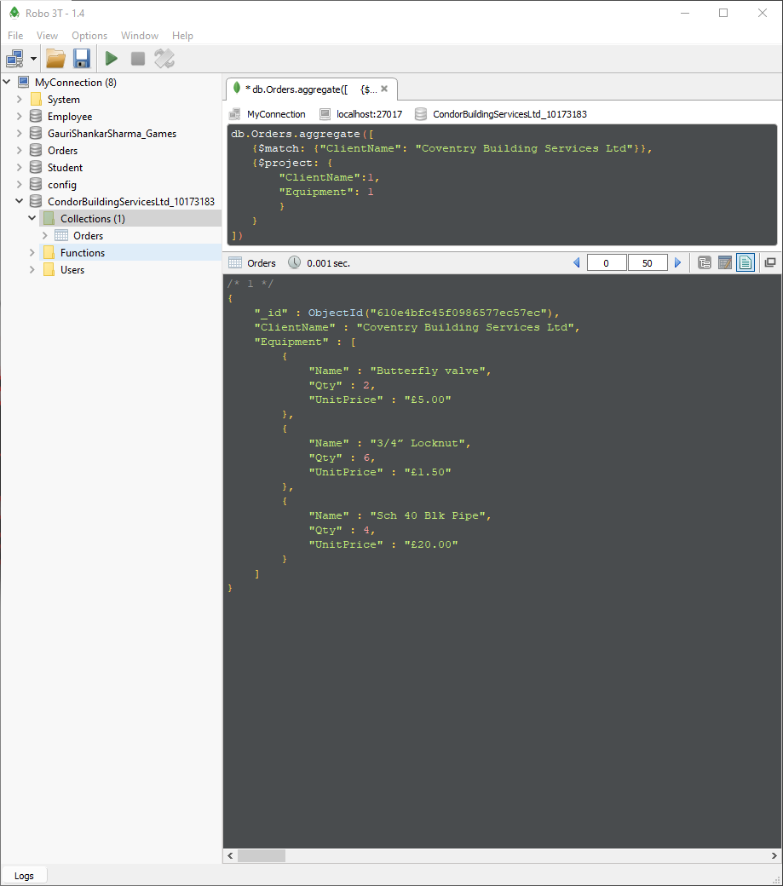

Figure 14: Displaying all the equipment associate with the client named ‘Coventry Building Services Ltd.

### **Q.N.6**

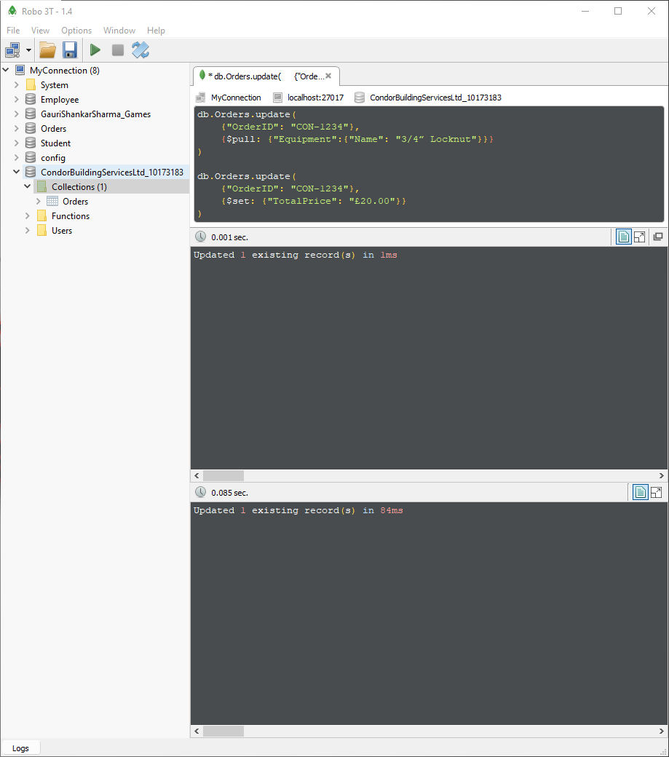

Figure 15: Deleting ‘3/4” Locknut’ from order id CON-1234 and updating the total price.

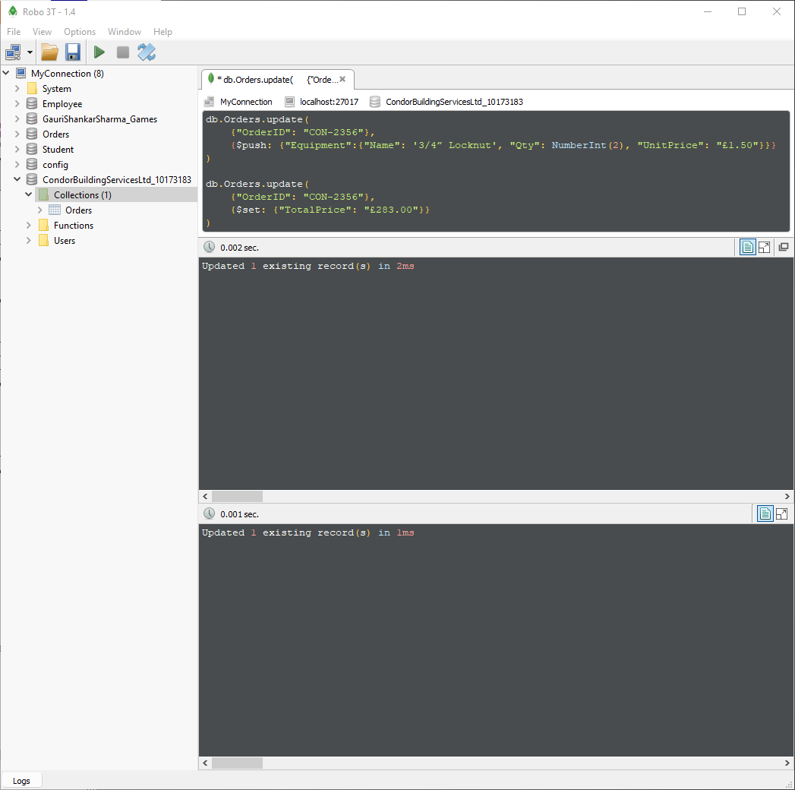

Figure 16: Putting ‘3/4” Locknut’ in order id CON-2356 and updating the total price.

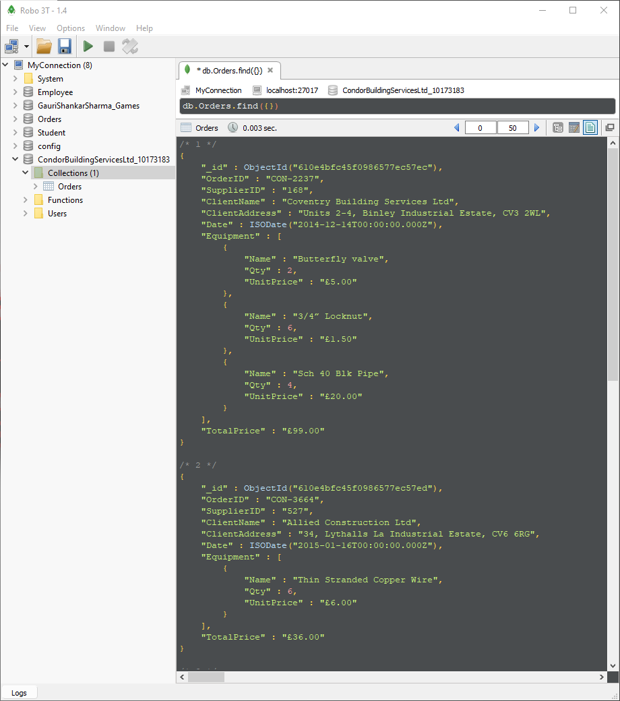

Figure 17: Displaying all the order details with its equipment it and total price after the changes in figure 15, 16.

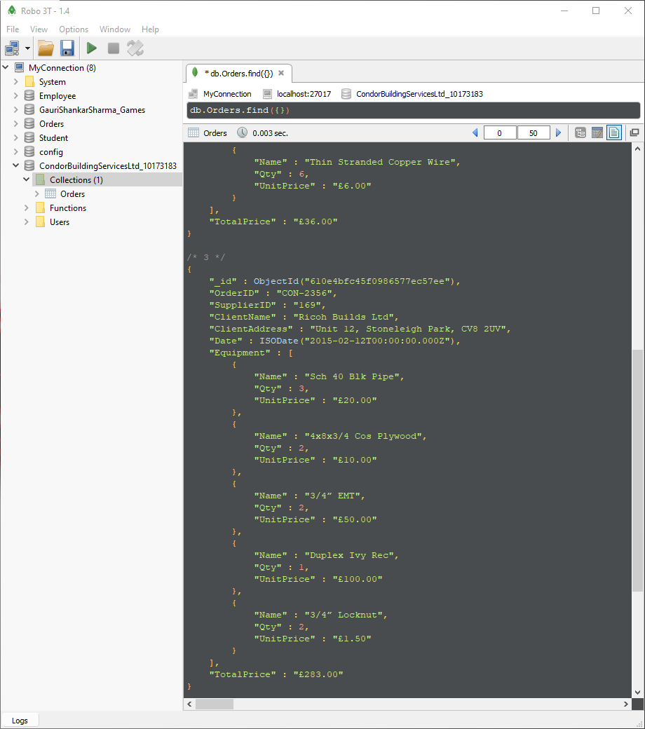

Figure 18: Displaying all the order details with its equipment it and total price after the changes in figure 15, 16.

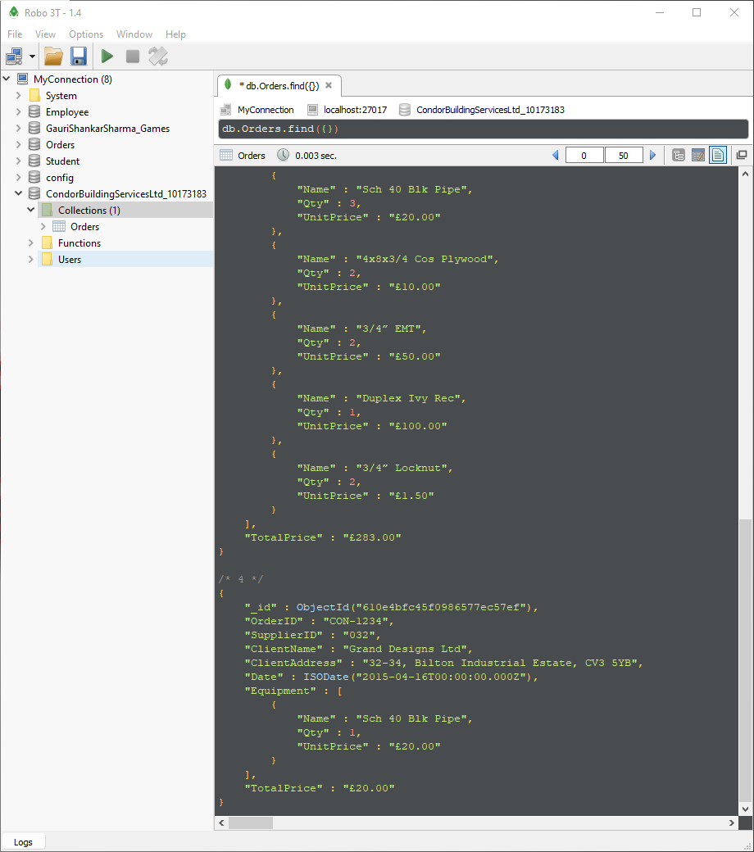

Figure 19: Displaying all the order details with its equipment it and total price after the changes in figure 15, 16.

### **Q.N.7**

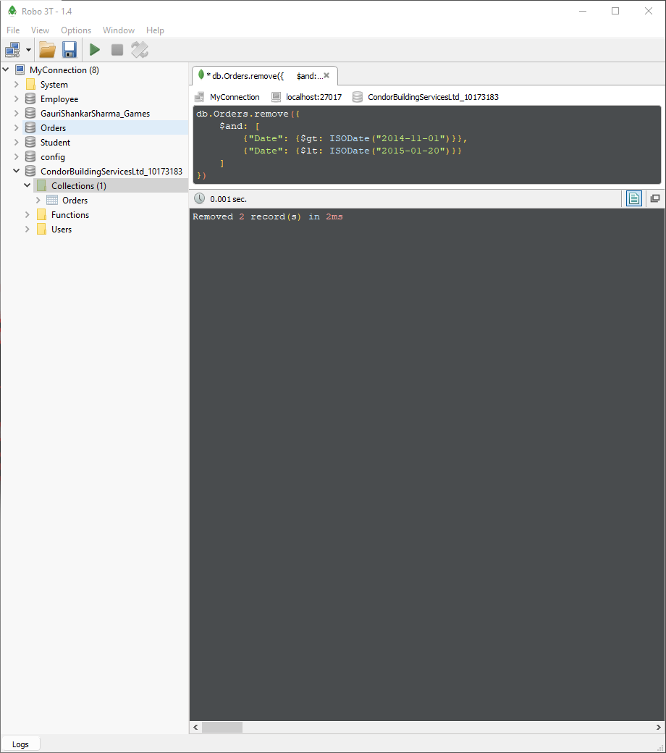

Figure 20: Deleting all the orders between 01/11/2014 and 20/01/2015.

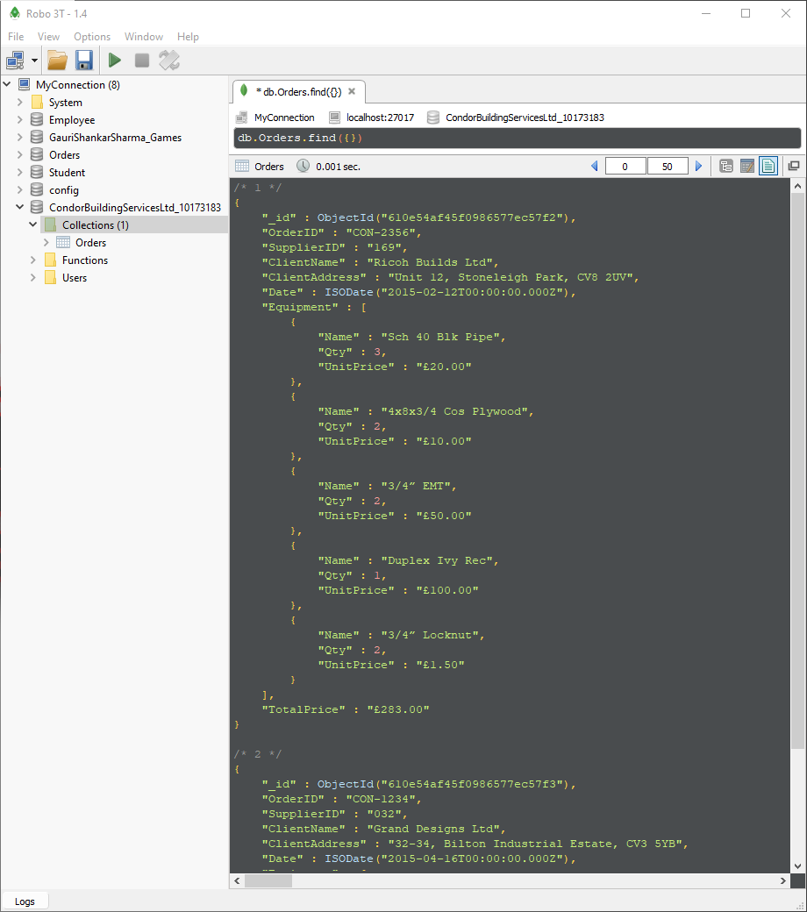

Figure 21: Displaying all the orders details with its client name and equipment after the changes in figure 20.

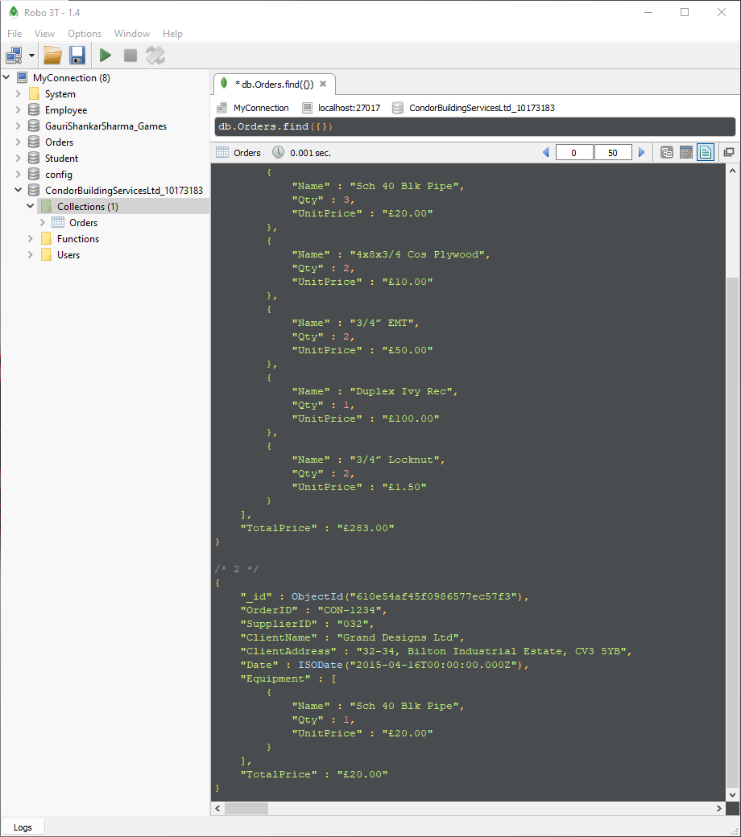

Figure 22: Displaying all the orders details with its client name and equipment after the changes in figure 20.